### **Step 1: Create, Extract, Compress, and Manage tar Backup Archives**

1. Command to **extract** the TarDocs.tar archive to the current directory:

**Tar xvf TarDocs.tar**

1. Command to **create** the Javaless_Doc.tar archive from the TarDocs/ directory, while excluding the TarDocs/Documents/Java directory:

**tar -cvf Javaless_Doc.tar --exclude TarDocs/Documents/Java TarDocs**



1. Command to ensure Java/ is not in the new Javaless_Docs.tar archive:

**tar tvf Javaless_Doc.tar | grep Java**



**Bonus**

* Command to create an incremental archive called logs_backup_tar.gz with only changed files to snapshot.file for the /var/log directory:



#### **Critical Analysis Question**

* Why wouldn't you use the options -x and -c at the same with tar?

### 

### 

### 

### 

### **Step 2: Create, Manage, and Automate Cron Jobs**

1. Cron job for backing up the /var/log/auth.log file:

**\* 6 * * 3 tar czf ~/Downloads/Tardocs/auth_backup.tgz /var/log/auth.log >/dev/null 2>&1**

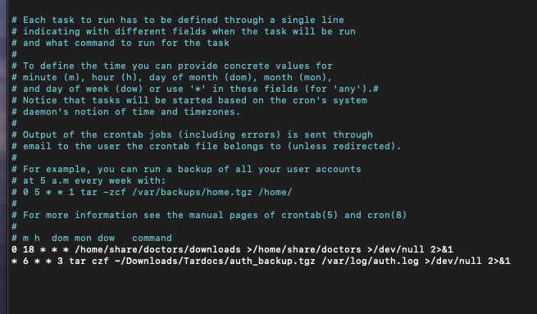

### **Step 3: Write Basic Bash Scripts**

1. Brace expansion command to create the four subdirectories:

**mkdir -p ~/backups/{freemen,diskuse,openlist,freedisk}**

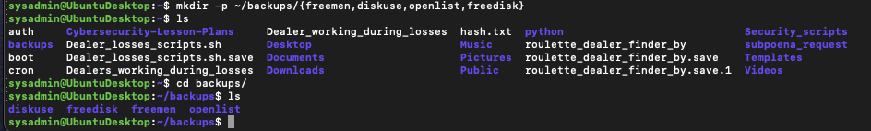

Paste your system.sh script edits below:  
#!/bin/bash

1. [Your solution script contents here]

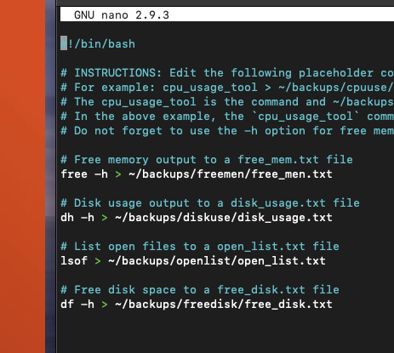

1. Command to make the system.sh script executable:

**Chmod +x system.sh**

**Optional**

* Commands to test the script and confirm its execution:

**./system.sh**

**Bonus**

* Command to copy system to system-wide cron directory:

### 

### **Step 4: Perform Various Log Filtering Techniques**

1. Command to return journalctl messages with priorities from emergency to error:

**journalctl -b -p emerg..err**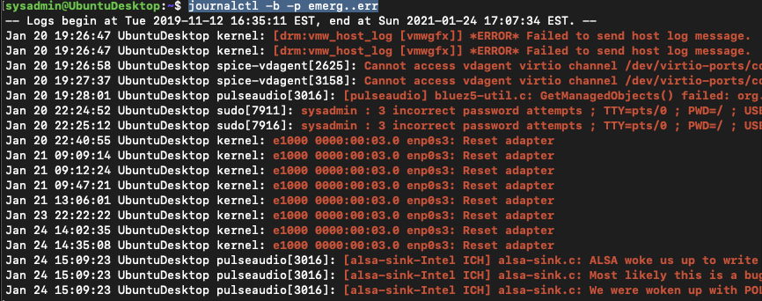

1. Command to check the disk usage of the system journal unit since the most recent boot:

**journalctl -b -u systemd-journald | less**

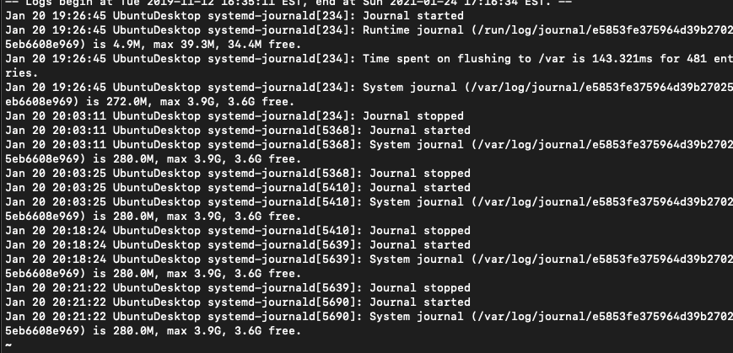

1. Comand to remove all archived journal files except the most recent two:

**sudo journalctl --vacuum-files=2**



**Bonus**

* Command to filter all log messages with priority levels between zero and two, and save output to /home/sysadmin/Priority_High.txt:
* Command to automate the last command in a daily cronjob:
* Add the edits made to the crontab file below:  
  [Your solution cron edits here]

### **Step 5. Create Priority-Based Log Files**

1. Command to record all mail log messages, except for debug, to /var/log/mail.log:
   * Add the edits made to the configuration file below:
2. [Your solution edits here]

**Bonus**

* Command to record all boot log messages, except for info and debug, to /var/log/boot.log:
  + Add the edits made to the configuration file below:
* **mail.!debug /var/log/mail.log**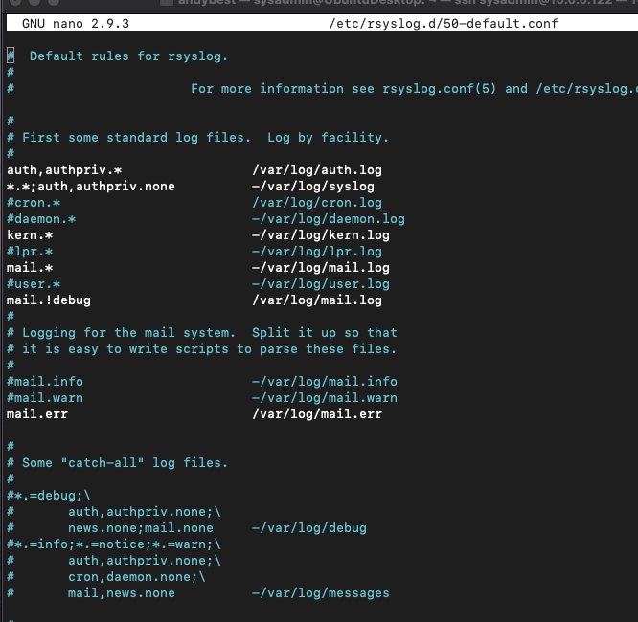

### **Step 6. Manage Log File Sizes**

1. Run sudo nano /etc/logrotate.conf to edit the logrotate configuration file.  
   Configure a log rotation scheme that backs up authentication messages to the /var/log/auth.log.
   * Add your config file edits below:
2. /var/log/auth.log {

weekly

rotate 7

notifempty

dailycompress

missingok

}

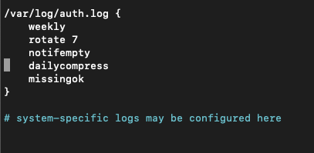

### **Bonus: Check for Policy and File Violations**

1. Command to verify auditd is active:
2. Command to set number of retained logs and maximum log file size:
   * Add the edits made to the configuration file below:
3. [Your solution edits here]
4. Command using auditd to set rules for /etc/shadow, /etc/passwd and /var/log/auth.log:
   * Add the edits made to the rules file below:
5. [Your solution edits here]
6. Command to restart auditd:
7. Command to list all auditd rules:
8. Command to produce an audit report:
9. Create a user with sudo useradd attacker and produce an audit report that lists account modifications:
10. Command to use auditd to watch /var/log/cron:
11. Command to verify auditd rules:

© 2020 Trilogy Education Services, a 2U, Inc. brand. All Rights Reserved.